Faculty of Computing and Informatics TPT2201 Industrial Training Student’s Weekly Logbook

|  |  |  |
| --- | --- | --- |
| Name of the Student | | Nik Ahmad Uzair bin Nik Ahmad Faisal |
| ID of the Student | | 1201200657 |
| Name of the Company | | Grab |
| Period of Training | | 3 Months |
| Name of the Company Supervisor | | Xiuying Qi |
| Name of the Faculty Supervisor | | Mr. Tong Gee Kok |
| Week Number/Report Period | | Week 4 |
| Brief Description of Tasks done during the Week  (8/5-8/9) | | * Made progress on the Jira ticket and committed changes. * Explored the Lang Chain framework and continued with Swift for iOS programmatic UI. * Created my first merge request (MR) and resolved a merge conflict based on reviewer feedback. * Scheduled a meeting with my buddy to review. |
|  |  |
|  |  | |

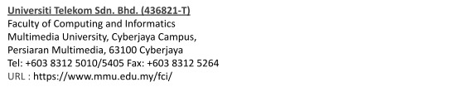

|  |  |
| --- | --- |
|  |  |
| Reflections (Problems encountered if any, Reasons for non-completion of planned tasks if any, Lessons learned, Tasks planned for the next week etc.) | **Blockers:**   * NIL   **Next Week Plan:**   * I will familiarize myself with Grab internal tools.   **Lessons Learned:**   * I learned about the use of each channel, and how the team is communicated. * I learned how to use advanced git   commands such as git rebase, squash and cherry pick. |
| Remarks from Company Supervisor (if any) |  |
| Signature of Company Supervisor with company stamp |  |

